**Mammogram Enhancement for Breast Cancer**

**Prediction (Image Processing)**

Department of Electronics & Communication Engineering, Vellore Institute of Technology,

Chennai, India

# A B S T R A C T

This research paper aims to develop a filtering model for mammogram enhancement and cancer prediction. The study utilizes a dataset of mammogram images and focuses on enhancing the quality of these images for improved detection of breast abnormalities. The dataset is preprocessed to remove noise and artifacts using various filtering techniques, and feature extraction techniques are employed to extract relevant information from the images. Several filtering techniques are evaluated for mammogram enhancement and detection, including median filtering, Gaussian filtering, and bilateral filtering. The performance of each technique is assessed using image quality metrics, such as peak signal-to-noise ratio (PSNR), structural similarity index (SSIM), and mean squared error (MSE). The results demonstrate that the proposed filtering techniques effectively remove noise and enhance the quality of mammogram images. The techniques achieve high PSNR, SSIM, and low MSE, indicating improved image quality and preservation of important details. These enhanced images contribute to more accurate and reliable detection of breast abnormalities. The study also identifies important features and patterns in the mammogram images that contribute to accurate detection. These features may include texture patterns, shapes, and intensity variations within the breast tissue. Understanding these features can aid in developing more precise and efficient algorithms for mammogram analysis. In conclusion, this research paper demonstrates the effectiveness of filtering techniques in enhancing mammogram images and improving breast abnormality detection. The results highlight the importance of preprocessing techniques, specifically filtering, in achieving accurate and reliable results. Further research could involve exploring different filtering techniques, optimizing their parameters, and investigating their impact on different types of breast abnormalities it incorporates the learned techniques to develop a new filter. The findings of this study contribute to the development of advanced tools for early detection of breast cancer and ultimately improve patient outcomes in breast healthcare.

# 1. INTRODUCTION

Breast cancer is a significant health concern affecting millions of individuals worldwide. It is a global health issue affecting people across different regions and nations. According to the World Health Organization (WHO), it is the most common cancer among women worldwide. In 2020, an estimated 2.3 million new cases were diagnosed, representing approximately 11.7% of all cancer cases. It is important to note that breast cancer can also occur in men, though it is much less common. Breast cancer incidence and mortality rates exhibit geographical variations. Developed countries, such as the United States, Canada, Australia, and various European nations, report higher rates compared to developing countries. These variations can be attributed to factors such as differences in healthcare access, early detection practices, lifestyle choices, and awareness about breast cancer screening.

Breast cancer arises from a combination of genetic, hormonal, and environmental factors. Genetic predisposition, such as mutations in the BRCA1 and BRCA2 genes, can increase the risk, but it accounts for a

small percentage of cases. Other factors include age, gender (with females being more susceptible), hormonal imbalances, a history of previous breast abnormalities, and exposure to radiation. Detecting breast cancer at an early stage is crucial for successful treatment. Common symptoms include the presence of a lump or thickening in the breast or underarm area, changes in breast size or shape, nipple discharge or inversion, skin dimpling or puckering, and persistent breast pain. Prompt evaluation by a healthcare professional is necessary for any unusual changes.

Breast cancer has a profound impact on individuals, families, and society. It is one of the leading causes of cancer-related deaths in women globally, accounting for 6.9% of cancer-related deaths in 2020. The emotional, physical, and financial burden of the disease affects not only the individuals diagnosed but also their loved ones.

Efforts to combat breast cancer have led to improved survival rates over the years. Early detection through regular mammography screenings, along with clinical breast exams and self-examinations, has played a pivotal role in achieving better outcomes. Treatment options, including surgery, chemotherapy, radiation therapy, targeted therapies, and hormone therapy, have also advanced, offering more personalized and effective approaches. Mammography plays a crucial role in early detection of breast cancer. Mammograms are X-ray images of the breast that can detect small abnormalities, including tumors or calcifications, even before they can be felt. Regular mammograms are recommended for women starting from the age of 40 or as per the guidelines of their healthcare provider. Mammography screenings have been shown to reduce breast cancer mortality by detecting cancers at earlier stages when they are more treatable.

Filtering techniques are instrumental in cancer prediction tasks as they enhance the quality and reliability of the input data. By applying filtering methods, such as noise removal or image enhancement algorithms, the data can be preprocessed to reduce noise and artifacts, making it easier to detect relevant patterns and features associated with cancer. Filtering helps to improve the accuracy of predictive models by eliminating irrelevant or misleading information. This enables healthcare professionals and researchers to make more precise predictions about cancer risk, diagnosis, and treatment outcomes, ultimately leading to improved patient care and better overall cancer management.

# 2. Related Work

Mammogram enhancement for cancer prediction involves techniques such as preprocessing, contrast enhancement, ROI extraction, feature extraction, and machine learning/deep learning approaches. These methods aim to improve image quality, extract relevant features, and build accurate prediction models. Research in this area continually explores new algorithms and advancements to enhance cancer detection from mammograms. Kimeya F. Ghaderi , Jordana Phillips, Hannah Perry, Parisa Lotfi, Tejas S. Mehta published a paper in Nov 7 2019 [1] where CEM was used an alternative to US and MRI to obtain contrast material–enhanced information and standard mammograms simultaneously. A CEM examination is shorter than that of MRI, and the modalities have similar rates of sensitivity to detect lesions. They evaluated clinical uses of CEM and discussed the literature supporting these indications. Maxine S. Jochelson and Marc B. I. Lobbes work on Contrast-enhanced

Mammography: State of the Art 2021 Mar 2 [2] talks about the details of CEM technique, diagnostic and screening uses, and future applications, including artificial intelligence and radiomics.

Impact of Image Enhancement Module for Analysis of Mammogram Images for Diagnostics of Breast Cancer by Yassir Edrees Almalki, Toufique Ahmed Soomro, Muhammad Irfan, Sharifa Khalid Alduraibi and Ahmed Ali 2022 Feb 26 [3] used techniques to process the mammography images in three channels (red, green and blue), then second step is based on the uniformity of the background on morphological operations, and then they obtained a well-contrasted image using principal component analysis (PCA). Next using a seed-based region growth technique pectoral muscle were removed, and the last step contains the coherence of the different regions of the image using a second order Gaussian Laplacian (LoG) and an oriented diffusion filter to obtain a much-improved contrast image. This produced drastically enhanced images which were excellent for cancer detection. In Enhancement of Mammographic Images Using Histogram-Based Techniques for Their Classification Using CNN by Khalaf Asharani,Hassan A. Alshamrani ,Fawaz F. Alqahtani and Bander S. Almutairi 26 December 2022 [4] both Contrast-limited Adaptive Histogram Equalization (CAHE) and Histogram Intensity Windowing (HIW) will be used (CLAHE). By improving the contrast between the image’s background, fibrous tissue, dense tissue, and sick tissue, which includes microcalcifications and masses, the mammography histogram was modified using these procedures. In this way they helped neural networks, learn, the contrast was increased to make it easier to distinguish between various types of tissue. The proportion of correctly classified images could rise with this technique.

G. R. Byra Reddy & H. Prasanna Kumar in their paper Enhancement of mammogram images by using entropy improvement approach 26 November 2019[5] proposed mammogram images enhancement by entropy improvement method by considering non-local filtered images. The methodologies would add to the effective discovery of masses and micro calcifications in mammograms.

Mammography Image Enhancement using

Linear,Nonlinear and Wavelet Filters with Histogram Equalization by Aziz Makandara and Bhagirathi Halallib 2017 [6] involved three steps: removing artifacts from the image, denoising the image using various filters, and increasing the contrast of the image through histogram equalization. The results of the experiments conducted on two standard datasets, MIAS and DDSM, showed promising results. Prannoy Giri and K Sarava April 18, 2017 [7] in their paper they quantitatively depict the analysis methods used for texture features for detection of cancer. These texture features are extracted from the ROI of the mammogram to characterize the microcalcifications into harmless, ordinary or threatening. These features are further decreased using Principle Component Analysis (PCA) for better identification of Masses. Back Propagation algorithm (Neural Network) is used for better understanding of the cancer pattern in the mammography image.

A Model for Mammogram Image Segmentation based on

Hybrid Enhancement by Kamal Nain Sharma, Amit Kamra 22.08.2020 [8] this paper put forward the methodology which will segment the affected area from the image. The image has been enhanced based on LCM and CLAHE. Morphology technique has been used along with the Otsu threshold for accurate segmentation. The proposed network is promising as it is trained for mammogram dataset for higher accuracy. Mammography Image

Analysis Society (MIAS) dataset is used in this work along with other clinical images which result in the creation of around 928 images in the dataset.

Computer Aided Diagnosis - Medical Image Analysis Techniques by Bhagirathi Halalli and Aziz Makandar talks about a CAD system which helps in achieving high accuracy, sensitivity which benefits for diagnosing mammography and the patients. The main goal of CAD systems was to identify abnormal signs at an earliest that a human professional fails to find. In mammography, identification of small lumps in dense tissue, finding architectural distortion and prediction of mass type as benign or malignant by its shape, size, etc.

A New Breast Border Extraction and Contrast Enhancement Technique with Digital Mammogram Images for Improved Detection of Breast Cancer by Manasi Hazarika, Lipi B Mahanta 07/08/2018 [9] results in breast border extraction method which was applied to 322 images of mini MIAS dataset. For the closing morphological operation, a line of length 10 and angle 15 degrees was taken as a structuring element. And for the morphological erosion operation they chose a disk structuring element of radius 2. After localizing the breast boundary, all the pixels outside appearing outside the breast boundary are masked by a zero value. Except a very few exceptional cases, labels along with some artifacts are appearing outside the breast boundary and so masking the area outside the breast boundary removes such labels and artifacts. Their method achieved a very good result for breast boundary extraction. Out of the 322 images, proposed method detected boundaries correctly in case of 318 images achieved 98.7% segmentation accuracy.



# 3. Proposed Methodology

The goal of this study is to enhance the outcomes and precision of mammogram detection through an improved filtering process, specifically by comparing different filtering techniques using PSNR and MSE. We have used Kaggle dataset for the following purpose over here and selected pairs of breasts combining cancerous, malignant, and normal breasts. The following steps were followed:

**3.1. Dataset collection:**

Mammograms are X-ray images of the breast used for breast cancer screening and diagnosis. The mammogram dataset available on Kaggle contain various attributes such as patient demographics, breast density, image characteristics, and diagnostic outcomes. It is utilized to develop algorithms and models for breast cancer detection and classification. Our dataset consisted the images of Cranio-Caudal (CC) view and Mediolateral Oblique (MLO) Fig.1 for a breast from which for structural comparison (CC) view images of breast were selected.

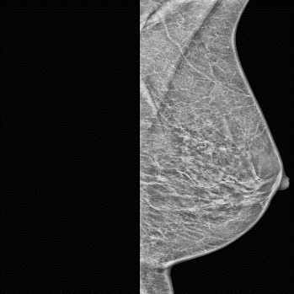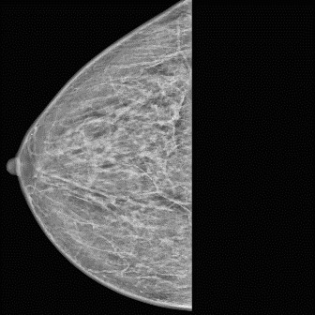

(a) (b)

Fig.1 (a) Cranio-Caudal CC view, the x-ray enters cranially and the film is located caudally. The x-ray beam in the CC view is parallel to the vertical axis of the body. (b) In an MLO view, the x-ray beam enters medially and the film is located laterally. The MLO view is not orthogonal to the CC view but oriented 30[degrees] to 60[degrees] to it.

**3.2 Breast X-ray comparison:**

Mammogram examination consists of various steps one of those is where the size of the breast is compared for detecting physical differences which can lead to early detection of abnormalities. In this process the size of the breasts is taken from the lower edge of the pectoralis muscle region to nipple perpendicular to it, the difference between the acquired values should not be more than 1 cm Comparing the images contain Cranio-Caudal (CC) view side by side for detecting physical similarities which can straight away help us in detecting abnormalities, saving us precious time and money for further examination. Percentage similarity calculation for prediction of NORMAL Fig.2(a) and ABNORMAL Fig.2(b) breast. For our process for early detection, we assigned 40% (cropping and sizing factors taken into consideration) as the limit for differentiating between a normal and an abnormal breast.

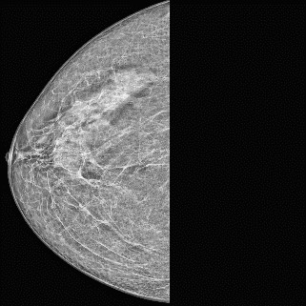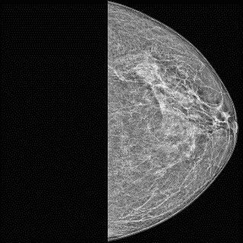

Fig.2(a) Similarity percentage between the X-rays greater than 60.

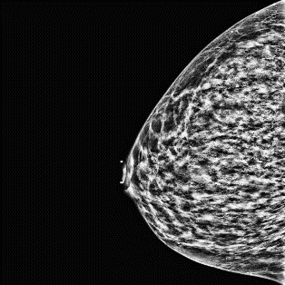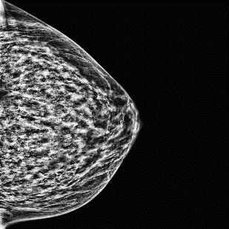

Fig.2(b) Similarity percentage between the X-rays less than 25.

**3.3 Preprocessing:**

Implementing preprocessing techniques to enhance the quality of the mammogram images. This may involve noise reduction, image normalization, and contrast stretching method to improve the clarity and consistency of the images. For our purpose we have used contrast stretching.

***3.3.1 Contrast stretching***: It is a technique used in image processing to improve the contrast of an image by expanding the range of pixel intensity values. Mathematically, contrast stretching involves mapping the original pixel values to a new range of values using a linear transformation.

Let's assume that the original pixel values range from a minimum value of `a` to a maximum value of `b`. The new range of values can be defined as a minimum value of `c` and a maximum value of `d`. The linear transformation can be expressed as:



In this equation, `Pin` is the original value of a pixel, and `Pout` is the new value after the transformation. The term ` (d - c) / (b - a) ` represents the slope of the straight line that maps the old range to the new range, and `c` is the yintercept.

By applying this transformation to all pixels in an image, we can stretch the contrast to improve the visual quality of the image.

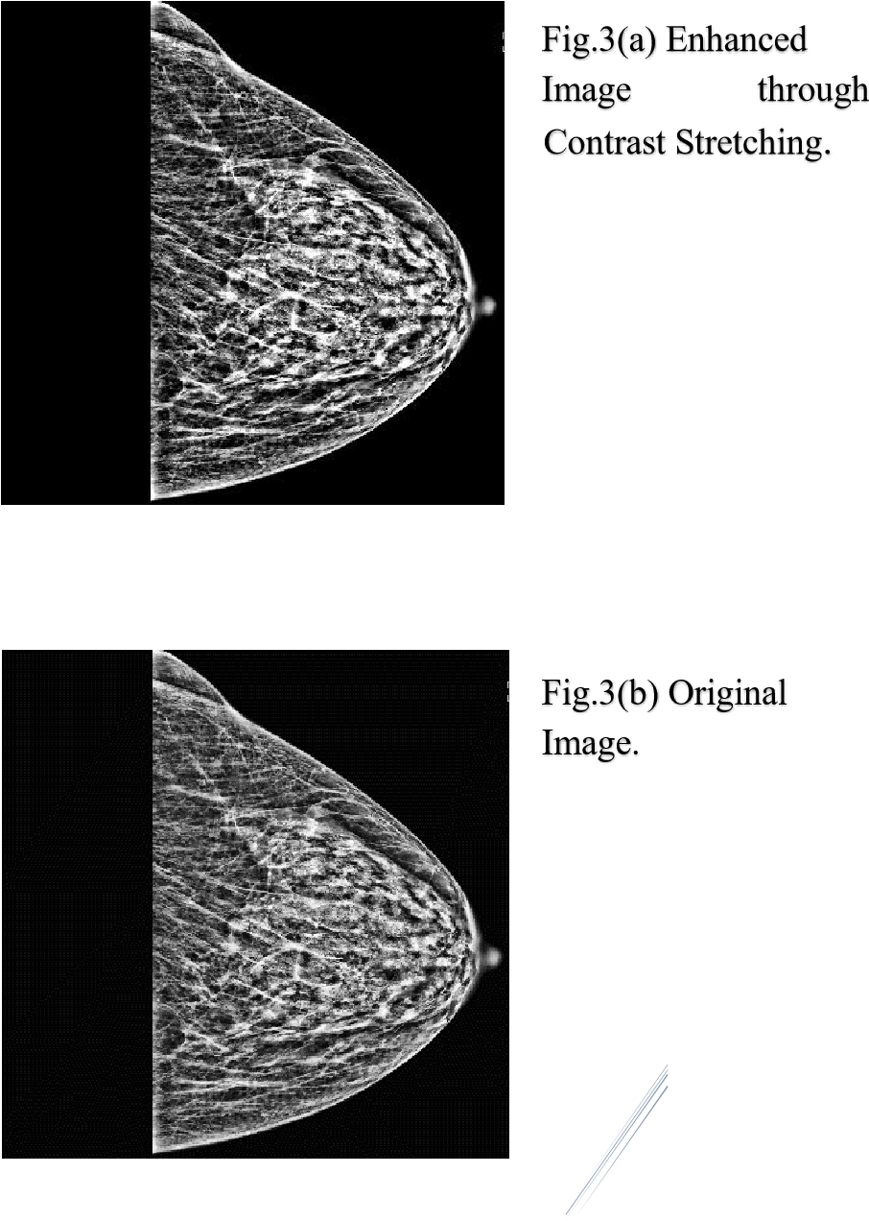

**3.4. Filtering:**

Exploring and evaluating different filtering techniques specifically tailored for mammogram analysis. We involved implementing various filters, such as Gaussian filtering1, Clahe filtering2, Weiner filtering3, Top -Hat filtering4. We developed our own filtering techniques through the mixture of the different filters. We have utilized customized filter kernel to an image using convolution5. Each technique will be applied to the mammogram images, and the resulting filtered images will be obtained.

*3.4.1 Gaussian Filtering:*

The idea of Gaussian smoothing is to use this 2-D distribution as a `point-spread' function, and this is achieved by convolution. Since the image is stored as a collection of discrete pixels, we need to produce a discrete approximation to the Gaussian function before we can perform the convolution. In theory, the Gaussian distribution is non-zero everywhere, which would require an infinitely large convolution kernel, but in practice it is effectively zero more than about three standard deviations from the mean, and so we can truncate the kernel at this point.

In 2-D, an isotropic (i.e., circularly symmetric) Gaussian has the form:



This distribution is shown in Fig.4(a).

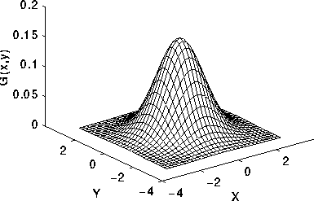

|  |
| --- |
| Fig.4(a) 2-D Gaussian distribution with mean (0,0) and sigma =1 |

We obtained noise reduction and smoothening of our mammograms through filtering Fig.4.1 (b).

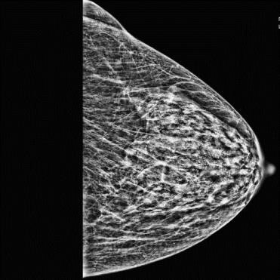

Fig.4.1 (a) Original image without processing.

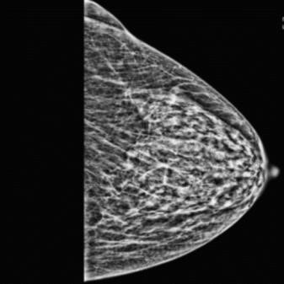

Fig.4.1 (b) Gaussian Filtering reduced noise smoothened image.

*3.4.2**Clahe Filtering:*

Adaptive histogram equalization (AHE) is a computer image processing technique used to improve contrast in images. It differs from ordinary histogram equalization in the respect that the adaptive method computes several histograms, each corresponding to a distinct section of the image, and uses them to redistribute the lightness values of the image. It is therefore suitable for improving the local contrast and enhancing the definitions of edges in each region of an image.

However, AHE tends to overamplify noise in relatively homogeneous regions of an image. A variant of adaptive histogram equalization called contrast limited adaptive histogram equalization (CLAHE) prevents this by limiting the amplification.

In CLAHE, the contrast amplification in the vicinity of a given pixel value is given by the slope of the transformation function. This is proportional to the slope of the neighbourhood cumulative distribution function (CDF) and therefore to the value of the histogram at that pixel value. CLAHE limits the amplification by clipping the histogram at a predefined value before computing the CDF. This limits the slope of the CDF and therefore of the transformation function. The value at which the histogram is clipped, the so-called clip limit, depends on the normalization of the histogram and thereby on the size of the neighbourhood region. Common values limit the resulting amplification to between 3 and 4.

It is advantageous not to discard the part of the histogram that exceeds the clip limit but to redistribute it equally among all histogram bins Fig.4.2(a).

Fig.4.2(a)

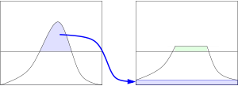

The redistribution will push some bins over the clip limit again (region shaded green in the figure), resulting in an effective clip limit that is larger than the prescribed limit and the exact value of which depends on the image. If this is undesirable, the redistribution procedure can be repeated recursively until the excess is negligible.

We obtained high contrast and edged images where the malignant tissues were better identifiable Fig.4.2 (c).

Fig.4.2 (b)Original Fig.4.2 (c)Clahe Enhanced

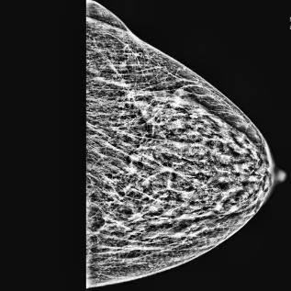

*3.4.3 Weiner Filter:*

In signal processing, the Wiener filter is a filter used to produce an estimate of a desired or target random process by linear time-invariant (LTI) filtering of an observed noisy process, assuming known stationary signal and noise spectra, and additive noise. The Wiener filter minimizes the mean square error between the estimated random process and the desired process.

A signal x[n] is to be modified, it approximates some other signal d[n] in some statistical sense. That is, the output of the filter y[n] is a good estimate of d[n]. The output error e[n] represents the mismatch between y[n] and d[n].

It minimizes the expected value of the squared error signal.

The outputs we got shows an enhanced malignant region the unnecessary tissues are subdued giving a better understanding of the lesion Fig.4.3 (b).

Fig.4.3 (a) Original image.

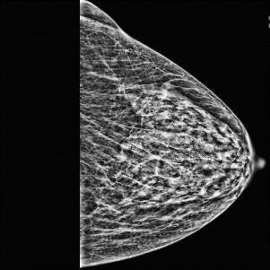

Fig.4.3 (b) Wiener Filter Image.

*3.4.4 Top-Hat transform (white):*

The top-hat transform is a technique used in image processing to enhance or extract small-scale structures from an image. It is commonly employed for tasks such as detecting small objects, enhancing local details, or removing background variations.

Involves two main steps: image opening and image subtraction.

I.

Image Opening:

The opening operation is performed on the input image

using a structuring element (e.g., a disk or a square).

Opening involves a combination of erosion and dilation

operations, which smoothens the image and removes larger

structures or bac

kground variations. The result is a

modified image that preserves the smaller

-

scale details.

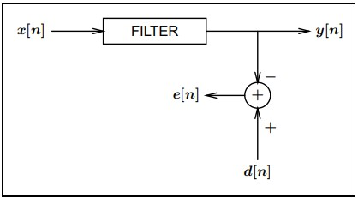

II. Image Subtraction:

The original input image is subtracted from the opened image. This operation highlights the small-scale structures or local details that were suppressed during the opening step. The resulting image, known as the top-hat image, contains the enhanced or extracted structures of interest.

The top-hat transform is especially useful when the structures of interest have a size comparable to or smaller than the structuring element used in the opening operation. It allows for the detection or enhancement of subtle features that might otherwise be challenging to observe.

Let's denote the input grayscale image as I and the structuring element used for the morphological operations as B. The top-hat transform (TH) can be expressed mathematically as: TH(I) = I - opening (I, B) here opening (I, B) denotes the opening of the image I using the structuring element B.

The structuring element B can have various shapes and sizes, such as a disk, square, or line, depending on the specific application and the desired level of detail enhancement.

White Top-hat transform gave us very good results but failed in high contrast images where the proportion of white portions was comparatively higher compared to the other X-rays Fig.3.4.

|  |
| --- |
| Fig.4.4 (a) Original X-Ray. (b)White Top-Hat transformed image. |

*3.4.5 Kernel and Convolution (Custom filter) *:*

1. Filter kernel: Also known as a convolution kernel or a filter mask, it is a matrix that specifies the weights used for convolution. It defines the spatial operations to be performed on an image, such as blurring, sharpening, edge detection, etc.

The weights which we used for the operations:

[1 5 1; 2 4 2; 1 2 1];

After multiple attempts the above combination gave the best output.

1. Convolution: Convolution is an operation that combines two functions (in this case, the image, and the filter kernel) to produce a third function (the filtered image). It involves sliding the filter kernel over the image and calculating the weighted sum of the overlapping pixels.

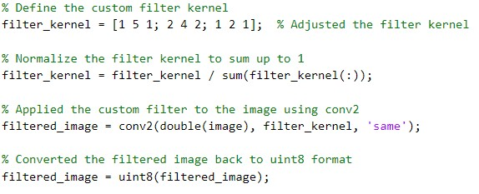

1. Normalization: In this context, normalization refers to the process of scaling the values in the filter kernel to ensure that their sum is equal to 1. This step is necessary to prevent any scaling effects when convolving the image with the filter kernel.
2. Double precision: It is a floating-point numeric format that uses 64 bits to represent a number. By converting the image to double precision (double(image)), more accurate calculations can be performed during the convolution process, resulting in a higher level of precision in the filtered image.
3. “uint8” format: It is an 8-bit unsigned integer format commonly used to represent grayscale or color images. In this code, converting the filtered image to uint8 format (uint8(filtered image) maps the pixel values to the range of 0-255, suitable for image display. Fig.4.5 (b) is the output of our custom filter.



Fig.4.5 (a) Original Xray.

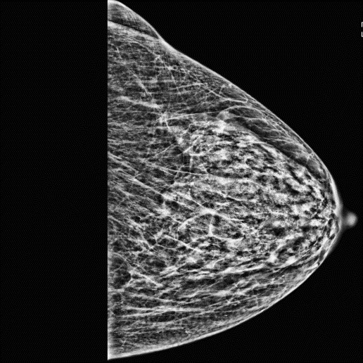Fig.4.5 (b) Filtered image with reduced clustering and more clarity.

**3.5. PSNR and MSE:**



Computing the PSNR1 and MSE2 values for each filtered image. PSNR measures the quality of the filtered image by comparing it to the original mammogram image, while (c) Custom made

MSE quantifies the average squared difference between the PSNR=27.0834dB

filtered image and the original image. These metrics provide objective measures of the performance of each filtering technique in preserving image details and reducing noise.

*3.5.1 PSNR:*



Peak Signal-to-Noise Ratio (PSNR) is an expression for the ratio between the maximum possible value (power) of (d) Weiner Filter a signal and the power of distorting noise that affects the PSNR=33.0104dB quality of its representation. Because many signals have a very wide dynamic range, (ratio between the largest and smallest possible values of a changeable quantity) the PSNR is usually expressed in terms of the logarithmic decibel scale.

* + - * 1. Mixed Filter

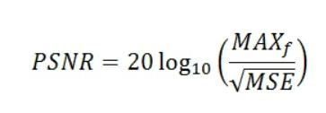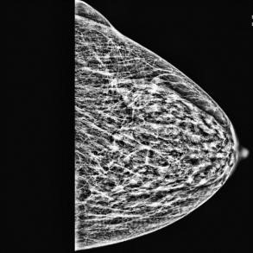In this experiment under investigation is the peak-signal-

PSNR=24.1947dB

to-noise ratio. If we can show that an algorithm or set of

algorithms can enhance a degraded known image to

resemble more closely the original, then we can more

accurately conclude that it is a better algorithm.

Below figures Fig.5 show the various images produced after applying different filtering techniques.

* + - * 1. White Top-Hat

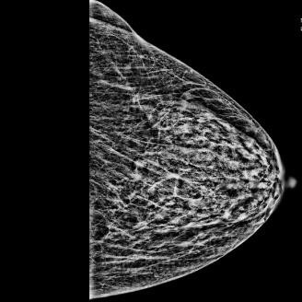(a) Original PSNR=24.06151dB

(g) Clahe

PSNR=23.5510dB

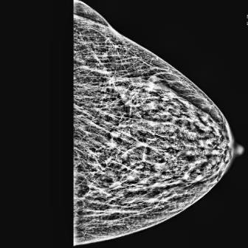(b) Gaussian

PSNR=22.9392 dB

*3.5.1 MSE:*

MSE is the most common estimator of image quality

measurement metric. It is a full reference metric and the values closer to zero are the better.

The MSE can also be said the Mean Squared Deviation (MSD) of an estimator. Estimator is referred as the procedure for measuring an unobserved quantity of image.

The MSE or MSD measures the average of the square of

the errors. The error is the difference between the estimator and estimated outcome. It is a function of risk, considering

the expected value of the squared error loss or quadratic loss.

Mean Squared Error (MSE) between two images such as

g (x, y) and gˆ (x, y) is defined as

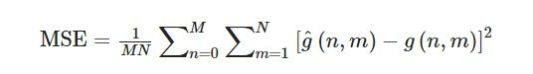

**3.6. Evaluation and selection:**

Analyzing the PSNR and MSE values obtained for each filtering technique. Comparing the results to identify the filtering technique that achieves the highest PSNR and the lowest MSE, indicating better image quality and noise reduction.

**3.7. Iterative refinement**:

Iteratively refining the selected filtering technique based on the evaluation results. This may involve adjusting parameters, exploring alternative variations of the chosen technique, or combining multiple filtering approaches to

further improve the image quality and noise reduction in mammogram analysis.

|  |  |  |  |  |  |  |
| --- | --- | --- | --- | --- | --- | --- |
| a (10 2). png | 22.55 77427  8 | 26.7  247  658  5 | 33.  207  529  4 | 25.639240 76 | 24.  527  414 14 | 25.0  755  056  4 |
| a (10 3). png | 22.23 51222  6 | 26.7  813  844  6 | 32.  329  241 12 | 26.583444 98 | 25.  621  787  9 | 24.4  379  368  9 |
| a (10 4). png | 21.87  99071  8 | 26.3  203  629  6 | 32.  049  716 49 | 27.723460 02 | 26.  291  421 01 | 24.0  398  316  8 |
| a (10 5). png | 26.22  67763  8 | 29.8  865  928  6 | 34.  287  395 82 | 18.722520 15 | 18.  360  637 25 | 11.3  882  065  4 |
| a (10 6). png | 29.37 66256  9 | 33.9  381  299  7 | 38.  870  891 81 | 19.518524 79 | 17.  846  104 97 | 10.4  877  684  7 |
| a (10 7). png | 23.56 45017  3 | 27.9  175  162  9 | 34.  333  046 65 | 24.200283  7 | 23.  592  046 72 | 22.2 1133 982 |

|  |  |  |  |  |  |  |
| --- | --- | --- | --- | --- | --- | --- |
| Ima ge Fil e | PSNR  _Gau  ssian_  Filter | PS  NR  _Va tsha l_Fi  lter | PS  NR _W  ien  er_ Filt er | PSNR_Mi  xed_Filter | PS  NR  _Cl ahe _Fil  ter | PSN R_T  opha t_Fil ter |
| a (1). png | 22.93 92251  7 | 27.0  834  704  7 | 33.  010  439 45 | 24.194726 22 | 23.  551  018 64 | 24.0  615  157  2 |
| a  (10  ).p ng | 24.55 76466  1 | 28.7  866  581  4 | 36.  106  563 92 | 26.402138 59 | 25.  533  816 62 | 22.8  926  338  5 |
| a (10 0). png | 25.51 45674  1 | 29.5  137  827  8 | 37.  277  587 48 | 21.480598 37 | 20.  335  271 57 | 18.6  767  583  1 |
| a (10 1). png | 22.19 50222  2 | 26.3  425  421  5 | 32.  797  977 76 | 26.787347 96 | 25.  200  921 46 | 25.2  279  963  3 |

**4. Result and Analysis:**

# 5. Conclusion

The techniques in the field of computer aided mammography include image pre-processing and various filtering technique which aid in detection of tumors and malignant tissues.

In conclusion, the study demonstrates the potential of our custom designed filter for image enhancement and prediction of cancerous tissues which came to near to the pre-existing technique Weiner filtering. Need for further research to improve the accuracy of the filter. The findings of this study can be used to develop more accurate and efficient mechanisms for image enhancement and can contribute to early-stage cancer detection.

**References:**

1.Contrast-enhanced Mammography: Current

Applications and Future Directions

Kimeya F. Ghaderi , Jordana Phillips, Hannah Perry, Parisa

Lotfi, Tejas S. Mehta

2.Contrast-enhanced Mammography: State of the Art Maxine S. Jochelson and Marc B. I. Lobbes

3.Impact of Image Enhancement Module for Analysis of Mammogram Images for Diagnostics of Breast Cancer by Yassir Edrees Almalki 1,*ORCID,Toufique Ahmed Soomro 2ORCID,Muhammad Irfan 3ORCID,Sharifa

Khalid Alduraibi 4ORCID andAhmed Ali 5

4.Enhancement of Mammographic Images Using Histogram-Based Techniques for Their Classification Using CNN by Khalaf Alshamrani ,Hassan A. Alshamrani ,Fawaz F. Alqahtani and Bander S. Almutairi

5.Enhancement of mammogram images by using entropy improvement approach

G. R. Byra Reddy & H. Prasanna Kumar 26 November

2019

6.Mammography Image Enhancement using

Linear,Nonlinear and Wavelet Filters with Histogram Equalization

Aziz Makandara, Bhagirathi Halallib 2017

7.Breast Cancer Detection using Image Processing Techniques

Prannoy Giri and K Sarava April 18, 2017

8.A Model for Mammogram Image Segmentation based on Hybrid Enhancement

Kamal Nain Sharma1, Amit Kamra2

9.Computer Aided Diagnosis - Medical Image Analysis Techniques

Bhagirathi Halalli and Aziz Makandar

**DOI:** [https://www.sciencedirect.com/science/article/pii/S18770](https://www.sciencedirect.com/science/article/pii/S1877050920300557)

[50920300557](https://www.sciencedirect.com/science/article/pii/S1877050920300557) [https://www.kaggle.com/datasets/chrisvatt/mamogramspreprocessed](https://www.kaggle.com/datasets/chrisvatt/mamograms-preprocessed)

<https://homepages.inf.ed.ac.uk/rbf/HIPR2/gsmooth.htm><https://stephenallwright.com/good-mse-value/>[https://link.springer.com/article/10.1007/s42452-019-](https://link.springer.com/article/10.1007/s42452-019-1728-1)

[1728-1](https://link.springer.com/article/10.1007/s42452-019-1728-1) <https://in.mathworks.com/matlabcentral/answers><https://www.ncbi.nlm.nih.gov/pmc/articles/PMC5638217/><https://youtu.be/aQW0LIcvHaY>[https://www.kaggle.com/datasets/chrisvatt/mamogramspreprocessed](https://www.kaggle.com/datasets/chrisvatt/mamograms-preprocessed) [https://www.researchgate.net/publication/310444490_Pre processing_digital_breast_mammograms_using_adaptive](https://www.researchgate.net/publication/310444490_Preprocessing_digital_breast_mammograms_using_adaptive_weighted_frost_filter)

[_weighted_frost_filter](https://www.researchgate.net/publication/310444490_Preprocessing_digital_breast_mammograms_using_adaptive_weighted_frost_filter) [https://stackoverflow.com/questions/55305623/errorusing-images-internal-imagedisplayparsepvpairs-inmatlab](https://stackoverflow.com/questions/55305623/error-using-images-internal-imagedisplayparsepvpairs-in-matlab) [https://en.wikipedia.org/wiki/Adaptive_histogram_equaliz ation](https://en.wikipedia.org/wiki/Adaptive_histogram_equalization) [https://www.ni.com/en-in/shop/data-acquisition-andcontrol/add-ons-for-data-acquisition-and-control/what-isvision-development-module/peak-signal-to-noise-ratio-asan-image-quality-metric.html](https://www.ni.com/en-in/shop/data-acquisition-and-control/add-ons-for-data-acquisition-and-control/what-is-vision-development-module/peak-signal-to-noise-ratio-as-an-image-quality-metric.html)

[Kernel (image processing) - Wikipedia](https://en.wikipedia.org/wiki/Kernel_(image_processing))